CRM nErgy Software Development Highlights
UPDATED VERSION

INCLUDE


Secured Communications eBox
In the CRM nErgy software – include a secured software chat inbox for communication between CRM nErgy’s Super Executive Admin [ SEA ] and KT software dev team.

AI Voice Agent

To build an AI voice agent, you typically connect a speech-to-text model, a large language model, and a text-to-speech model in a streaming pipeline. This setup allows the agent to listen, understand, and respond to users in real-time.
Building an AI voice agent involves creating a system that can interact with users through spoken language. This typically requires integrating several key components to ensure smooth and natural conversations.
Overview of AI Voice Agents
Building an AI voice agent involves creating a system that can interact with users through spoken language. This typically requires integrating several key components to ensure smooth and natural conversations.
Key Components
1. Speech-to-Text (STT)
- Converts spoken language into text.
- Essential for understanding user input.
2. Large Language Model (LLM)
- Processes the text input to generate intelligent responses.
- Acts as the core of the agent's conversational abilities.
3. Text-to-Speech (TTS)
- Converts the generated text responses back into spoken language.
- Provides a natural-sounding voice for the agent.
Streaming Pipeline
The interaction between these components follows a specific pipeline:
Component | Function
Speech-to-Text | Converts audio input to text
Large Language Model | Generates a response based on the text input
Text-to-Speech | Converts the text response back to audio
This streaming pipeline allows the voice agent to listen, think, and respond in real-time, creating a seamless user experience.
Implementation Steps
- Set Up the STT Model: Choose a reliable speech recognition service to convert audio to text.
- Integrate the LLM: Use a large language model to process the text and generate responses.
- Implement the TTS Model: Select a text-to-speech service to convert the responses back into audio.
- Test and Optimize: Ensure that the entire system works smoothly, minimizing latency and improving response accuracy.

Google Maps in Territory Management

Google Maps is used in territory management to help visualize geographic areas for sales representatives, allowing for route optimization and efficient scheduling. However, it lacks advanced features like prospect counts and demographic data, which are essential for effective territory management in a CRM context.
Key Features of Google Maps in Territory Management
- Route Optimization: Helps sales reps find the best routes to their appointments, saving time and reducing travel costs.
- Geographic Visualization: Provides a clear view of the areas assigned to each sales rep, aiding in planning and organization.
- Offline Access: Allows users to access maps without an internet connection, which is beneficial for field sales.

Summary Table of Benefits
Benefit | Description
Organized Sales Data | Segments data by regions for better management.
Focused Coverage | Ensures all areas are adequately covered by sales reps.
Reduced Overlap | Minimizes confusion and resource wastage.
Streamlined Reporting | Simplifies performance insights by territory.
Accurate Sales Projections | Enhances forecasting accuracy through performance analysis.
Automated Lead Assignment | Saves time with automated routing of leads.
Efficient Resource Use | Maximizes productivity by focusing on specific territories.
Territory management features are essential for optimizing sales strategies and improving overall business performance.

Internal Search Engine Bar:

Search docs, tasks, files and others with AI

Fully Translatable into Spanish CRM ERP

[ CRM ERP software ] and [ CRM ERP website ]

Instant Website Translation
website pages and funnels can be viewed in English or Spanish with just one click—no extra plugins required. [ I seen this on a competitor’s site ] I work with Spanish speaking clients this is very necessary.
I spend a lot of time in California.

Tutorial Training Videos

Comprehensive tutorial videos are essential for understanding and utilizing CRM features effectively. These resources help users grasp terminology and learn how to navigate various functionalities within CRM systems.

FAQs DATA SEARCH BAR ENGINE
8/11/2026 Aug 11, 6:07 AM
Yes, we can make this much smarter than a normal FAQ system by using an AI-powered centralized Knowledge Base with RAG. The main benefits would be: - All FAQs and product knowledge managed from one central place - The same knowledge can automatically serve 100+ website pages - Visitors can ask questions naturally instead of searching manually - AI answers based on your actual CRM/ERP information, reducing incorrect answers - New questions and information can be added anytime without changing every page - We can identify questions customers are asking that aren't yet in the knowledge base - The same system can later power your website assistant, CRM assistant, ERP assistant, customer support, and AI agents - We can use open-source/free RAG technology for much of the system and connect an AI API only where needed, helping control ongoing costs. So instead of building just an FAQ section, we build one central AI knowledge system that grows with the entire platform.

Customizable Dashboards

[ Drag-and-Drop Interface ]

Easy to navigate CRM, a clean and streamlined user friendly interface that allows users to quickly access the features they need without getting lost in complex menus.

Customizable dashboards and smart bookmarks can enhance usability and efficiency.

How do customizable dashboards enhance CRM user experience?
Easy navigational CRM features Drag-and-Drop interface, which allows users to easily organize and manage contacts, tasks, and sales pipelines with minimal clicks. This intuitive design enhances user experience and productivity by simplifying common tasks.
Customizable dashboards enhance CRM user experience by allowing users to tailor the interface to their specific roles and responsibilities, presenting only the most relevant information. This targeted approach improves productivity and helps users focus on key performance indicators that matter most to their tasks.
Comparison of CRM Features
Feature | Description | Benefits
Drag-and-Drop Interface | Allows easy organization of tasks and contacts | User-friendly, efficient
Intuitive Dashboard | Customizable view of key metrics and tasks | Quick access to important info
Streamlined Contact Management | Easy addition and retrieval of contact information | Saves time, reduces frustration
Task Reminders | Automated notifications for follow-ups | Ensures timely actions
Pipeline Visibility | Visual representation of sales opportunities | Enhances tracking and management
These features collectively contribute to a more efficient and enjoyable user experience, making CRMs easier to adopt and use effectively.

EXAMPLE: 1
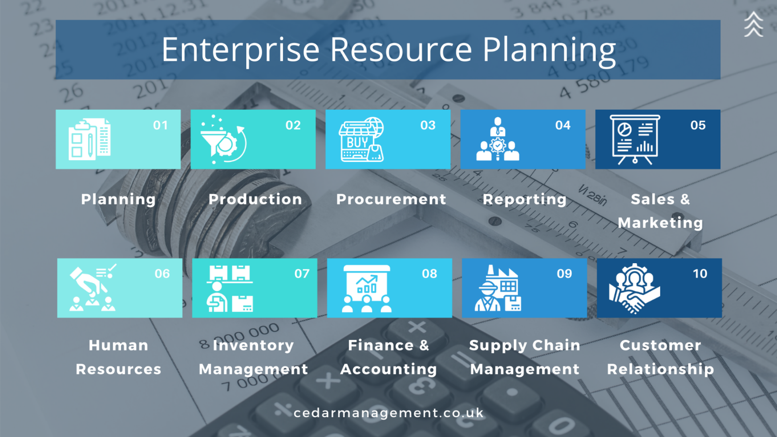

EXAMPLE: 2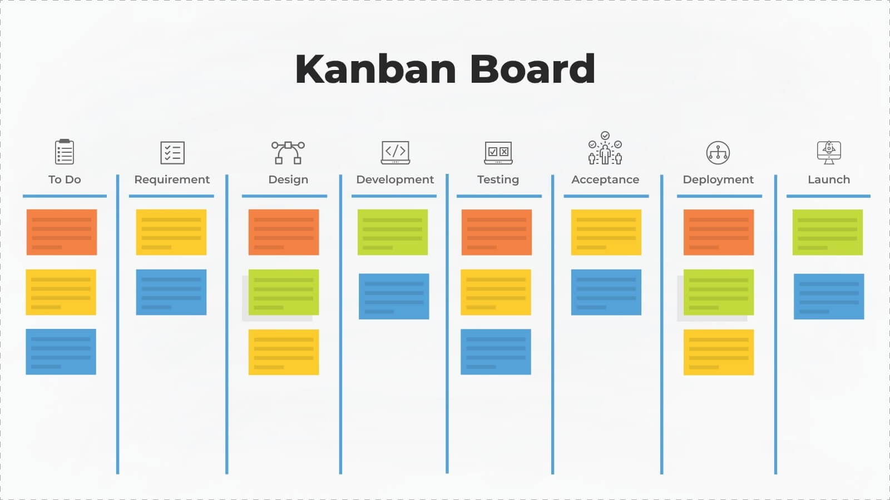
EXAMPLE: 3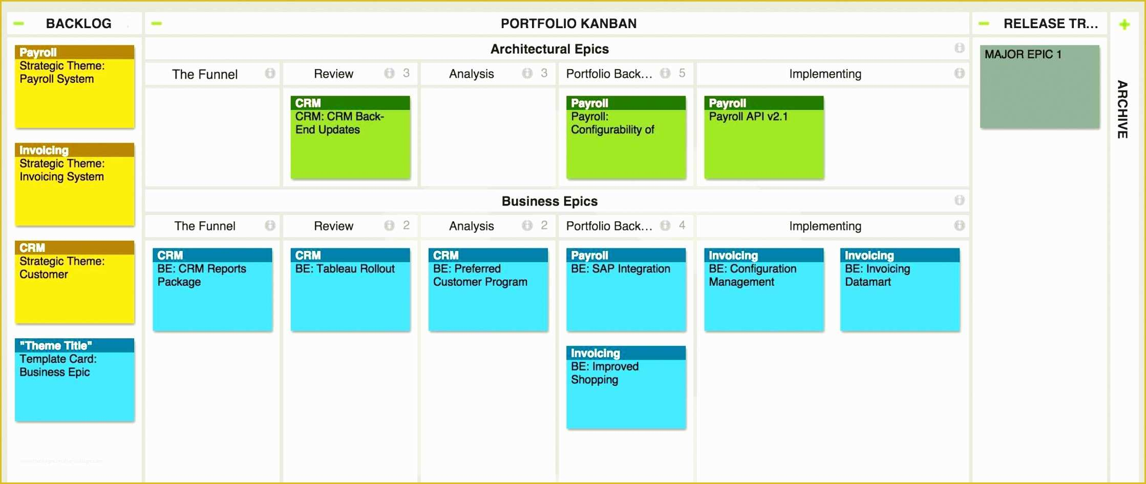
EXAMPLE: 4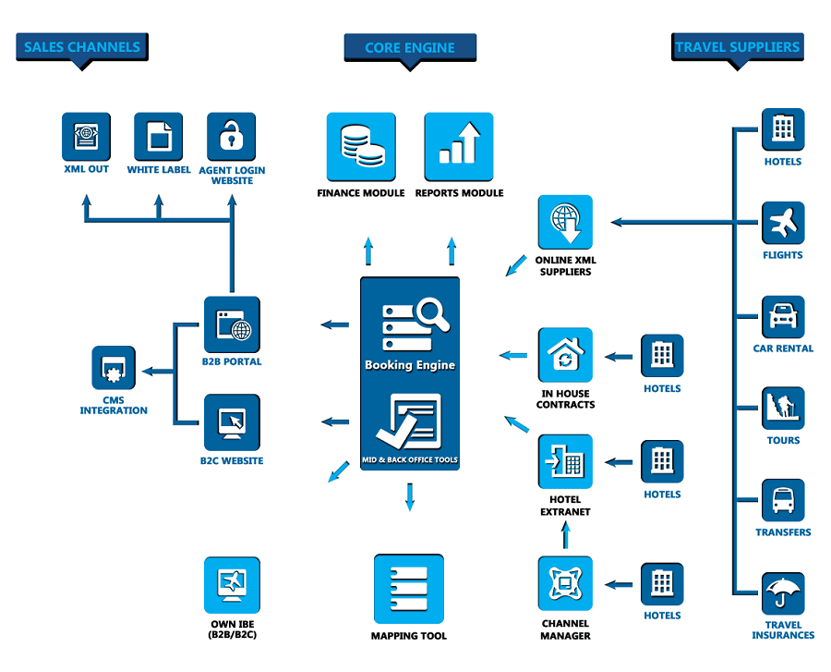
https://www.provab.com/apis-xmls/wp-content/uploads/2025/12/Amadeus-Software-1.png
EXAMPLE: Reports & Analytics
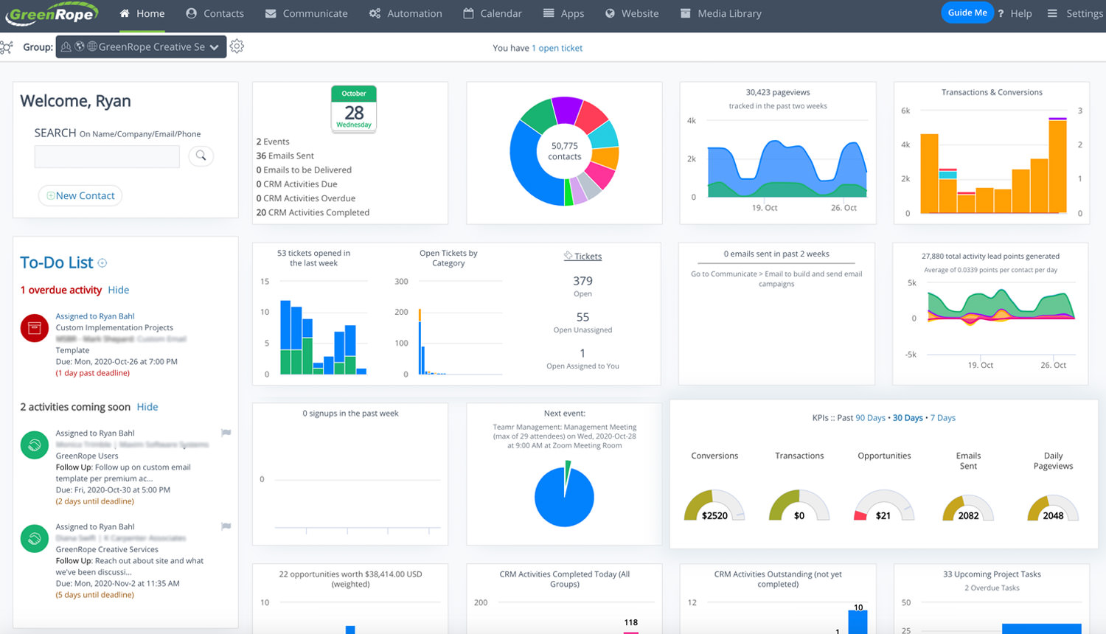
https://app.greenrope.com/users/myteam29042/Media1787.jpg

